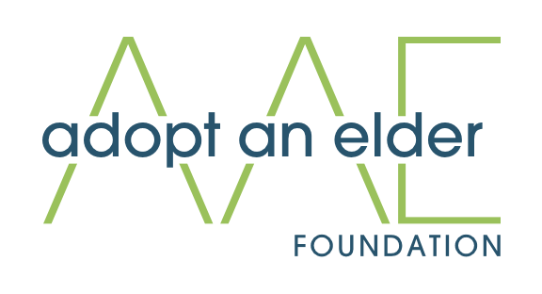

**Adopt an Elder Foundation**  
PO Box 1603  
Rocklin Ca, 95677  
Info@adoptanelderfoundation.org  
[Www.AdoptAnElderFoundation.org](http://Www.AdoptAnElderFoundation.org)

We are excited to share a heartfelt invitation to become a sponsor for **The Giving Gala**, hosted by the **Adopt an Elder Foundation**, taking place on **October 23, 2025**

This elegant evening is more than just a celebration—it is a mission in motion. The Giving Gala marks a milestone for our foundation as we raise critical funds to address the unmet needs for dignified living for the elderly in our local communities. We believe every elder deserves peace of mind, safety, and respect in their golden years, and with your help, we can make that vision a reality.

**What to expect at the Giving Gala:**

* An elegant evening featuring dinner, dancing, and community
* Powerful stories of impact from those whose lives have been transformed
* An opportunity to sponsor or raise funds through personalized giving pages

**95% of all proceeds** go directly toward housing support, essential services, and quality-of-life improvements for seniors in need—powered by our all-volunteer Board of Directors and an incredible network of generous volunteers.

We invite you to join us as a **Gala Sponsor**, sponsorship offers not only brand visibility at our event, but more importantly, it aligns you with a cause that uplifts and restores dignity to our most vulnerable elders.

Enclosed is our sponsorship packet with detailed levels and benefits.

Thank you for considering this opportunity, we look forward to the possibility of partnering with you for this unforgettable evening of generosity, compassion, and hope.

**🎗️ Giving Gala Sponsorship Opportunities**

*October 23, 2025 | 6:00 PM | Location TBD*

**🌟 Legacy Sponsor – $10,000**

* Premier Sponsor recognition in all event materials (full ad in the event program), press releases, and social media platforms
* Logo prominently featured on step-and-repeat backdrop
* Reserved VIP table for 10 guests
* Opportunity to speak during the gala program
* Featured in post-event thank-you campaign
* Personalized giving page for donor outreach
* One Year’s recognition on the Adopt an Elder Foundation Website

**💛 Dignity Sponsor – $5,000**

* Featured recognition in event materials (half-page ad in event program) and social media
* Logo featured on step-and-repeat backdrop
* Reserved VIP seating for 5 guests
* Verbal recognition during program
* Personalized giving page
* One Year’s recognition on the Adopt An Elder Foundation Website

**💐 Compassion Sponsor – $2,500**

* Logo placement on select event materials
* Reserved seating for 4 guests
* Recognition during event slideshow
* Acknowledgement in event program
* Personalized giving page

**🕊️ Hope Sponsor – $1,000**

* Recognition in printed program and website
* Reserved seating for 2 guests
* Name listed on event signage
* Personalized giving page

**🤝 Friend of the Foundation – $500**

* Name listed in printed program and website
* Reserved seating for 1 guest
* Access to personalized giving page

Don’t have the ability to sponsor directly or want to do more? No problem! Create a personalized giving page, and if your funds equal to a sponsorship level, you’ll receive all the same sponsor recognition and benefits for that level and earns you a seat at the table!

*All sponsors receive tax acknowledgment for their contribution and a follow-up impact report after the event.*